Question:1
A movie theater charges different ticket prices. Kids under 5 are free. Seniors (65+) get a discount. Adults pay the standard price. Write a program that takes a person's age and prints their ticket price ("Free", "Discount", or "Standard").
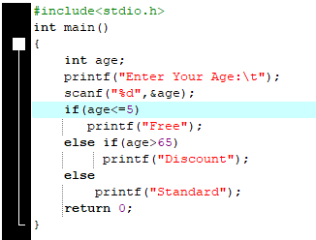
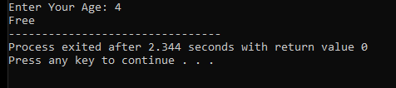
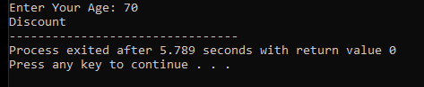
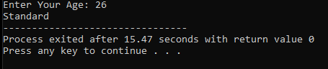
Question:2
A traffic light system works in two stages. First, it checks if the power is on (powerOn is 1). If the power is on, it then checks the lightColor ('R', 'Y', 'G') to decide the action: "Stop" for red, "Caution" for yellow, "Go" for green. If the power is off, it should always print "Signal Off". Write the code for this system
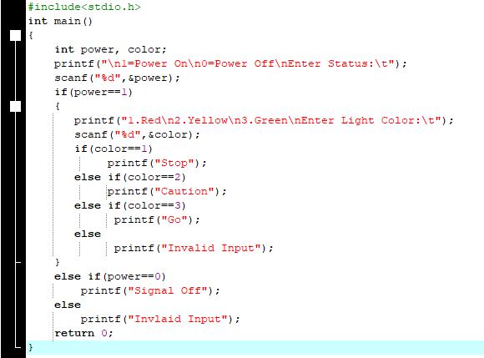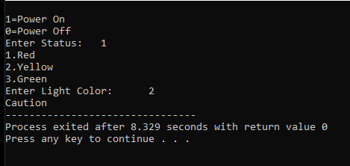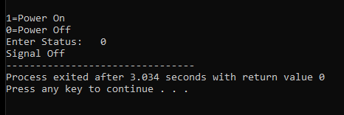
Question: 3
Write a program to solve a quadratic equation ax² + bx + c = 0. Input a, b, c. - Use to calculate the discriminant.
- If discriminant > 0 → two real roots.
- If discriminant = 0 → one real root.
- If discriminant < 0 → imaginary roots
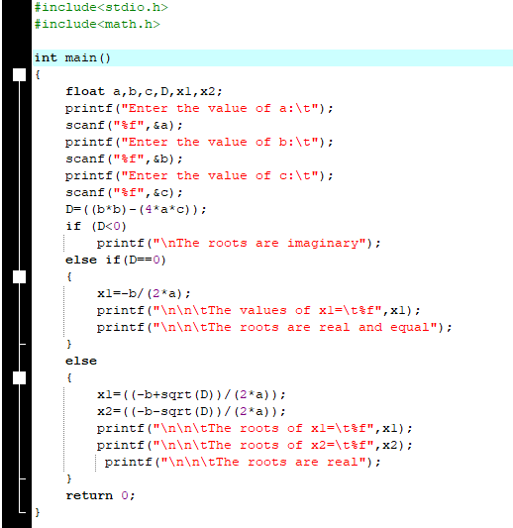
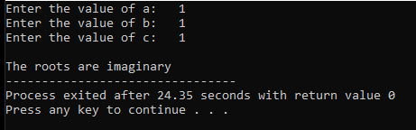
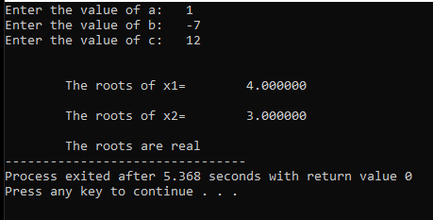
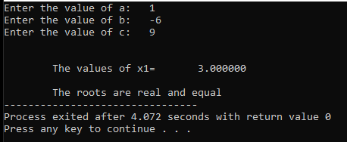
Question:4
An online account login has two security checks. First, it checks if the username is correct. If it is, it then checks the password. If both are correct, it logs the user in. However, if the username is correct but the password is wrong, it should give a specific error: "Incorrect password". If the username itself is wrong, the error should be "Username not found". Write the complete nested logic for this.
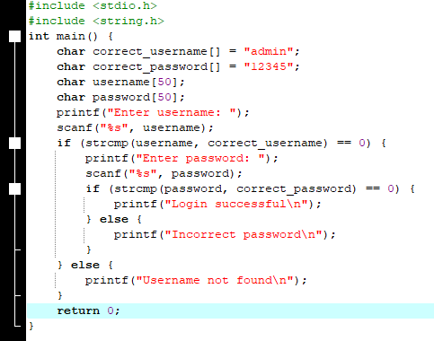
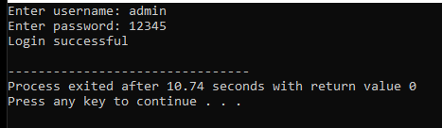
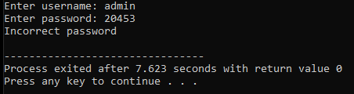
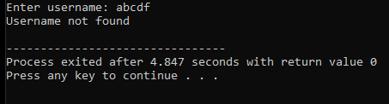
Question:5
A university has rules for course enrollment. A student can only enroll if they have completed the prerequisite (hasPrerequisite is 1). If they have the prerequisite, then they can enroll if the course is not full (isCourseFull is 0). Write the logic that prints one of these four precise messages: "Enrolled successfully", "Cannot enroll: prerequisite missing", "Cannot enroll: course is full", or "Cannot enroll: prerequisite missing and course is full.
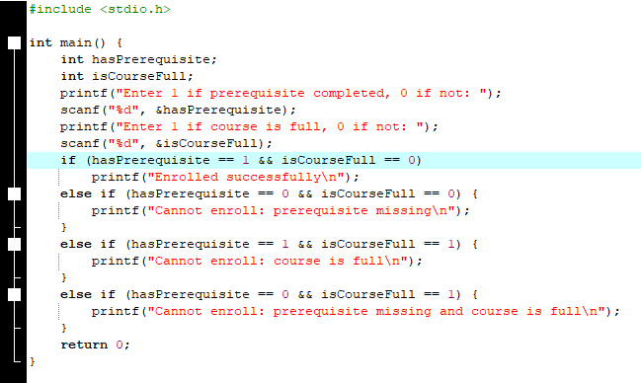
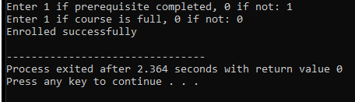
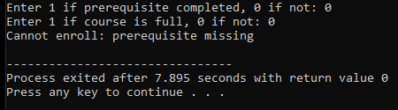

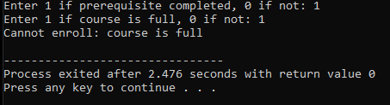
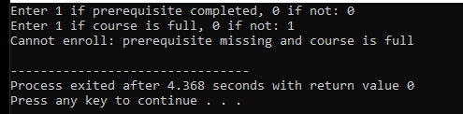
Question:6
A smart home system controls appliances based on the room and the desired action. The system first asks for the room ('L' for Living Room, 'K' for Kitchen). Then it asks for the action ('L' for Lights, 'T' for Thermostat).
The specific command depends on the combination:
- Living Room Lights: "Adjusting ambient lighting."
- Living Room Thermostat: "Setting living room temperature."
- Kitchen Lights: "Turning on bright task lighting."
- Kitchen Thermostat: "Setting kitchen temperature."

Write a program that takes these two character inputs (room and action) and uses a nested switch statement to print the appropriate command for the smart home system.
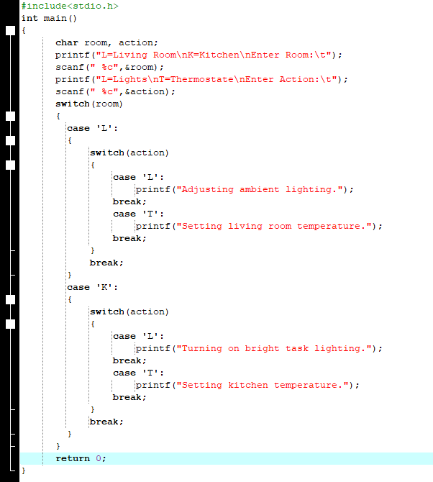
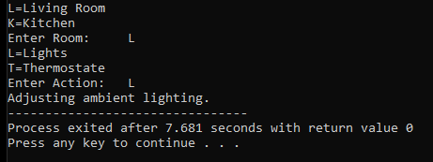
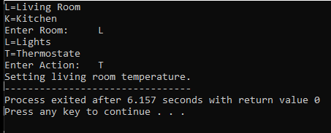
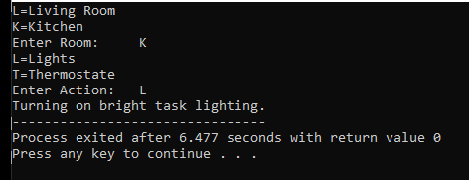
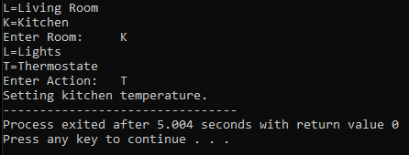
Question:7
A program checks user permissions stored in a single integer variable permissions. The value is a combination of flags: 1 (binary 001) for READ, 2 (binary 010) for WRITE, and 4 (binary 100) for EXECUTE.
The access rules are:
- If a user has the EXECUTE permission, print "Access granted: full control".
- If a user does NOT have EXECUTE but has both READ and WRITE, print "Access granted: read and write".
- If a user has only READ, print "Access granted: read-only".
- Otherwise, print "Access denied".
Write a nested if-else statement that uses bitwise operators to check these bits in permissions and prints the correct message.
